Contents

Concept 2

Phoneme System - Einstein speaks to you 2

User Profile – Einstein learns about you 3

Games and Activities – Einstein plays with you 4

Involuntary Activities and Interactions 4

Achievement System – Einstein rewards you 5

The Professor 5

OFFLINE Mode 6

Navigation - Core Word 6

Offline Activities 6

CLOUD CONNECTED Mode 7

Navigation - Cloud Word 7

Connected Activities 7

APP CONNECTED Mode 7

The Stein-O-matic 3000 (Mobile App) 8

My Profile – Getting Personal 9

Chalkboard – Interacting with the professor 9

Pi Chart – Scheduling Daily Activities 10

Brain Games – Exercising your gray matter 10

My Research 11

DIALOG/FLOW 1 – Connecting Einstein 12

DIALOG/FLOW 2 – Navigating Einstein’s Content Using Keywords 17

# Concept

*The intellect of the 20th century’s most well known scientific genius has been downloaded into a twelve- inch tall robotic body and is looking for a worthy assistant and companion to pass on his knowledge and insight. Lucky you!*

Einstein is an interactive, connected toy containing light robotics and featuring experiences that focus on imagination, personalization and STEM-focused learning. As the user’s constant companion, Einstein will teach and play via an expandable library of activities.

The Einstein doll employs light robotics to display facial expressions during speech and allow for limited, bi-pedal mobility. A phoneme-based text to speech system allows extensive and expansive dialog.

Play is driven by the internet connected Einstein ‘doll’ in concert with the accompanying mobile App (the Stein-O-matic 3000 science tool!) with which both the user and the doll seamlessly and continuously interact. Einstein will react constantly through vocal responses with the user, as he/she engages each activity on the Stein-O-matic, offering helpful hints and encouragement during play.

*Most games use the doll and the mobile App in concert to create a unique ‘companion’ centered experience; however, when the doll is offline, there is a limited library of on-board content that can be enjoyed.*

Meta concept and themeing

Like the man himself, activities with Einstein are driven by humor and imagination. For the purpose of playfulness and fun, Einstein will have an understanding that his intellect has been placed into a small robot. This will allow us to generate some humorous scenarios and dialog.

The general tone of Einstein’s conversation with the user will be light-hearted and playful, as in this sample dialog:

EINSTEIN  
Ooh-hoo-hoo, hello there! So nice to see a friendly face after being in a state of psycho-kinectistasis for so long! Ahhh, it’s wonderful to finally wake up and smell the atoms! (chuckles) So, let’s get things started, shall we?

## Phoneme System - Einstein speaks to you

Einstein will do a lot of talking in his recognizable, german accent.

Details on the phoneme system will appear here as they are developed.

A great reference for Einstein’s voice can be found here: <https://www.youtube.com/watch?v=OamFZCFfQkg>

Expressions  
When interacting with the user, facial motors will display a range of expressions and emotions.

Range of expression is TBD

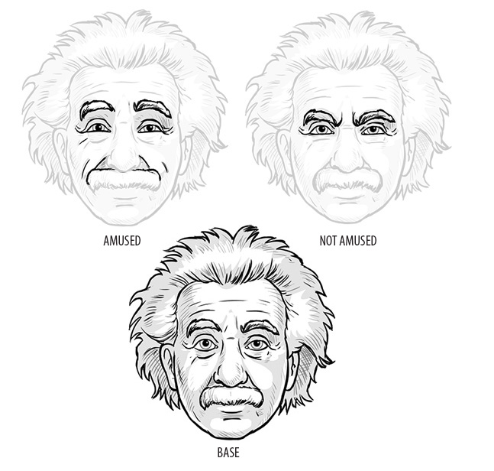

## User Profile – Einstein learns about you

Personal information about the user is collected in a User Profile database and is accessed and used as indicated in the Games and Activities sections of this document. Whenever possible, games and activities integrate the user’s profile information in order to personalize the experience.

Information is added to the User Profile via the Stein-O-Matic 3000 App or through certain verbal interactions with Einstein – such as when he asks the user their favorite color*.*

Profile Information

*This section will be expanded throughout development. Data that is part of the Limited User Profile is TBD*

* Personal info
  + Name
  + Age
  + Birthday
* People
  + Family
  + Friends
  + Frenemies
* Favorites Info
  + Color
  + Movies
  + Books
  + Games
  + School subject
  + Songs
  + Actors
  + Musicians
  + etc

## Games and Activities – Einstein plays with you

The user can play games and activities with Einstein, the extent of which is limited by the doll’s current connectivity mode. Games vary widely in depth of play. Additionally, most games REQUIRE the doll to be in a fully connected mode and the user to have access to the mobile App.

* Takeaway games are downloaded into Einstein and can be played in offline mode. See OFFLINE Mode below.
* Brain Games are accessed through the Stein-O-matic and can only be played when Einstein is fully connected.

Games can be accessed through verbal command with the Einstein doll, by navigating to the game via keywords; or launched directly from the mobile App. A few games do not require the Stein-O-matic 3000 App to play, but most use the App in conjunction with the doll for a highly interactive experience.

Games and activities are described in the various sections below. They are first pass and will be detailed, swapped out or eliminated entirely as development continues.

### Involuntary Activities and Interactions

Involuntary activities are events that are not triggered by the user. Rather, they are scheduled based on the user’s position in the leveling system or some other trigger hidden from the user.

These interactions include:

* Jokes – Einstein will, on occasion ask the user if he/she would like to hear a joke.
* Chalkboard Challenges – Occasionally, Einstein will leave a question to answer, or puzzle to solve on the Stein-O-matic’s Chalkboard. Chalkboard Challenges are available for play in offline and fully connected modes, but new Chalkboard Challenges are only received when fully connected. See Chalkboard – Interacting with the professor below.

## Achievement System – Einstein rewards you

Achievements and disbursement of some content are designed around a leveling system.

Advancing in the leveling system will:

* Unlock rewards
* Unlock content
* Award the user with Achievement Badges
* Unlock new avatar pieces
* Unlock Special Einstein interactions and responses
* Change the user’s current Title (which starts as ‘Assistant’)

To increase his/her level the user earns IQ points by:

1. Excelling at BrainGames (see BrainGames)
2. Completing any task Einstein sets (see Chalkboard Challenges)
3. Providing certain Profile information (see My Profile)
4. Interacting with Einstein in certain ways can also reward IQ points

The player can always check his/her level progress in the Stein-O-Matic 3000 by selecting the Profile icon and choosing My Progress.

Additionally, Einstein will always use the user’s current Title appropriately during spoken conversations.

# The Professor

Einstein can exist on 1 of 5 different MODES based on his connectivity status. Einstein’s current MODE determines what content is accessible to the user and the extent of interaction possible with Einstein at that moment.

1. FULLY CONNECTED – Einstein is Fully Connected when he is connected to both the internet (cloud service) and the mobile app. In this MODE, Einstein has access to all features.
2. CLOUD CONNECTED – When Einstein is connected to the internet, but not the mobile App, he has expanded knowledge functions and a more robust ability to parse a user’s spoken keywords and phrases, but no direct App interaction is possible. *During this stage, when the mobile app is loaded, it will constantly remind the user to connect Einstein; and Einstein will frequently do the same.*
3. APP CONNNECTED – It’s possible that Einstein is not setup to access the internet, setup fails or Einstein temporarily looses the connection. In this case, Einstein will be able to interact with the mobile App features, but will not have access to cloud features (or they will be greatly slowed/reduced.)
4. OFFLINE – When Einstein is not connected to the internet or the mobile App, he only has access to his onboard (keyword-based) communication tree and downloaded/take-away features. In this state, both Einstein and the mobile App will frequently insist on ‘getting connected.’
5. STANDBY – When Einstein is in standby, he is waiting for the user to say the *wakeup* word.

## OFFLINE Mode

The robot is in offline mode when it has no connection to the internet or to the mobile App.

WHEN OFFLINE, Einstein has reduced functionality and can only access a Limited User Profile and offline activities.

Details on offline functionality will appear here as it is developed.

### Navigation - Core Word

In offline mode, Einstein reacts to a core set of words that allow the user to navigate the limited offline content menu.

*Core Menu content is TBD, but includes:*

* Wake up/get attention command
* Tell me about [App] functionality
* Let’s Talk (branch 1)
* Let’s Play (branch 2)
* What time is it?
* Quick Play (Offline Activities only)
* Enter profile info

### Offline Activities

In offline mode, Einstein has access to a limited set of onboard/takeaway content.

Offline activities will appear here are the tech features are clarified. We’re confident that an activity like Imagine This! (see below,) driven only by verbal keyboard interaction, will be possible.

Imagine This!

Imagine This! is a MadLibs style story (playable in offline mode) wherein Einstein asks the user to provide options to seed some fantastic, and possibly made up, stories of the professor’s misadventures. In addition to initial choices, information from the user’s profile is added to fill in additional details. Finally, as Einstein tells the story, the user is offered points at which the user can make decisions that change the course of the story.

*An enhanced version of Imagine This! is available if Einstein is connected to the Stein-O-matic App.*

Details on specific onboard/takeaway activity content will appear here as it is developed.

Note: In Full or Cloud Connected modes, Einstein is able to download new takeaway content.

## CLOUD CONNECTED Mode

Einstein can connect to a local Wi-Fi router.

When connected, Einstein can access the cloud service.

Connection to the cloud service will provide the following expanded features:

* Expanded siri/Cortana/google voice style internet search queries
* Expanded verbal navigation (cloud word, see below)
* Useable Knowledge such as weather, location based information, *…*
* TBD

When connected, Einstein will provide answers to natural spoken queries IF the user asks a question and Einstein does not detect an existing keyword (eg. Siri/google Voice query). *The exact nature and extent of this interaction is TBD.*

### Navigation - Cloud Word

In cloud connected mode, Einstein will react to a far wider range of verbal commands and queries.

Cloud queries

If Einstein does not recognize a keyword, the sentence will be sent to the cloud service to be parsed as a siri/Cortana/google voice style query.

Details are TBD based on technology discussions.

### Connected Activities

When Einstein is connected to the internet only, he has access to his cloud connected subset of activities.

Details are TBD based on development discussions, but will be drawn from the list of Activities defined in the Activity section below.

## APP CONNECTED Mode

Einstein can connect directly to the Stein-O-matic mobile App.

When connected, Einstein can trigger UI actions and, conversely, can respond verbally to user actions taken when engaging the UI.

*Note: Quick reactions from Einstein, based on action taken by the user within the mobile App, is essential to this Einstein experience.*

Details are TBD based on technology discussions.

# The Stein-O-matic 3000 (Mobile App)

Early on in the setup process, Einstein introduces the user to a key piece of scientific equipment that he refers to as the Stein-O-matic 3000.

The ‘3000’ is an app with a retro 50’s aesthetic and will, in Einstein’s words “help us organize our searches, our games, our work, and our experiments!”

The App drives all sorts of quick interactive moments between the user and the doll, provides daily activities and tests setup by Einstein himself to challenge and expand the user’s mind, offers a couple in-depth video game-like experiences (that can be expanded in future downloads), provides the user a visual window into his/her profile and progress as a genius-in-training, allows the user to schedule Einstein’s activities each day… and more

Interaction with the doll

The Stein-O-matic 3000 companion App enhances the interaction with the Einstein doll in many ways.

The App is directly connected to the doll’s internal router and ‘knows’ when Einstein is online. Furthermore, it can communicate directly with the doll (and vice versa) allowing Einstein to:

* React quickly to actions taken within the App.
* Place visual cues on the App’s screen (in addition to verbal help) to coincide with the user’s actions within a game, or as a means of prompting the user what to do next.

A priority of the App is to ensure Einstein is connected as much as possible. When it detects that Einstein is offline it will (frequently) remind the user to connect him. Additionally, ghosted/inactive icons serve as a reminder to the user that additional functionality is available ONLY if Einstein is connected.

Using the App

Once the App is installed and Einstein is connected to it, he will frequently react verbally to the user’s actions within the App.

The App consists of several main content areas, each of which can be accessed via an icon on the main menu:

* My Profile
* Chalkboard
* Pi Chart (activity scheduler)
* Brain Games
* My Research

Menu options may be expanded to accommodate additional functionality as development continues.

### My Profile – Getting Personal

Selecting the My Profile icon will allow the user to manage his/her profile and other personalizations. The profile ‘module’ of the Stein-O-matic let’s the user access different areas:

* The personalizer
* My avatar
* My progress

The user can navigate easily between these section by swiping the screen left or right.

#### The Personalizer

User Profile information can be entered directly into the user’s profile by selecting via the personalizer. The user can easy select and enter info such as “First Name”, “Last Name” or “Birthdate.” OR select a Favorites list and enter his/her favorite color, song, artist, etc. When connected, Einstein has access to ALL information stored in the User Profile.

Note that profile information will be collected when using other sections of the App as well, or when in conversation with Einstein. For example, when playing a certain game, Einstein may ask the user for information. If this information is relevant to his/her profile, it will be stored appropriately in the User Profile.

#### My Avatar

The user’s avatar appears in the profile section of the App. The user’s avatar consists of a line drawing that represents what the user will look like when he reaches the level of galactic genius as envisioned by the Stein-O-matic’s prediction engine. The engine takes into account all of the user’s profile information as well as his/her current IQ level and other information from conversations with Einstein to assemble the avatar.

The Stein-O-matics prediction engine receives new information frequently, so that walrus mustache probably won’t stick around forever! Luckily, the user can take a snapshot and share the picture with his friends at any time.

Initially, the avatar is an amusing rendering that is generated solely by a few preliminary questions at setup, but as the user unlocks additional avatar items, he/she can have more control over their appearance. Avatar unlocks include a pleasant selection of mustaches, imposing eyebrows and eyewear, professorial hairdos, suitably scientific clothes and other items.

My Progress

The user’s progress up the IQ ladder can be viewed in the progress section of the Stein-O-matic, along with any achievement badges that have been earned along the way.

### Chalkboard – Interacting with the professor

At any time, the user may find that the Professor has assigned him/her a number of Chalkboard Challenges. The user is always alerted to a new Chalkboard Challenge by Einstein himself, but the number of active challenges also appears on the Chalkboard icon.

Chalkboard Challenges are time Insensitive micro-activities. That is, they do not expire and can be completed at any time (or dismissed by the user entirely.) Examples of Chalkboard Challenges would be:

* Einstein asks the user a knowledge based question. The user may need to search the internet for the answer, or maybe just ask Einstein!
* Einstein asks the user a word puzzle.
* Einstein requires the user to solve a (grade appropriate) math problem.
* Einstein requires the user to solve a visual complete the circuit or gear style puzzle – Einstein has no patience for engineering! The completion time determines the number of IQ points earned.
* Etc

The user is rewarded with IQ points, and kudos from Einstein himself, for every Chalkboard Challenge completed.

*Note: It is essential that Chalkboard Challenges are entertaining but extremely easy to design and implement so that future development on new chalkboard content packs is as small as possible.*

### Pi Chart – Scheduling Daily Activities

The Pi Chart is a 12-hour, pie-chart style interface that allows the user to schedule different activities such as activities and reminders. Events in the Pi Chart are ‘downloaded’ into Einstein and will automatically trigger at the appropriate time.

### Brain Games – Exercising your gray matter

In the Brain Games section of the Stein-O-matic 3000, the user can engage in more in-depth games, with verbal aid and encouragement provided by Einstein. Brain Games challenge the user with the following hand-eye coordination, brain agility and brain training challenges:

Snapshot

Snapshot tests a user’s object recognition and brain agility. In it, Einstein places shapes onto the screen, one shape at a time, as a timer counts down. When all of the shapes are on the screen, they form a recognizable object. The user gains points by guessing what the object is, with the number earned based on how much time is left in the timer. The quicker the object is guessed; the more points the user earns. To guess, the user just verbalizes the answer to Einstein (or selects from on-screen multiple choice answers,) who will tell the user if he/she guessed correctly. In addition, Einstein will sometimes provide hints. When the player guesses the object, or perhaps after a grouping of like objects is completed, a simple blurb fact about the object(s) appear(s).

Snapshot can be scaled up in difficulty by requiring the user to rotate incoming object pieces so that they fit, before being able to guess.

Imagine That [Enhanced]

Imagine That! [Enhanced] is the Stein-O-matic enhanced version of the story activity that can be played with Einstein in offline mode.

Imagine That [enhanced] operates in much the same way as the offline version except that the user can interact with a visual representation of the story, and make expanded story choices via time limited option icons.

Several story types will be available, including storylines that can be ‘failed’ if the correct choices are not made. The user will earn ‘points’ for stories that are successfully completed.

Lab Rat

The Lab Rat game is TBD

*Note: The Brain Games section of the mobile App is designed to be expanded with additional content packs.*

### My Research

The research section of the Stein-O-matic records any information ‘learned’ by the user over the course of interacting with Einstein. It is a log of sorts that can save the information collected by the user’s Einstein questions and cloud searches. The research section can expand into a more fully-featured science journal, if desired.

# DIALOG/FLOW 1 – Connecting Einstein

The following flow chart and dialog sheet are first pass examples of how Einstein might lead the player verbally through the process of getting connected to the internet and the mobile App. This section also serves as an example of how keywords may be employed.

* **White blocks** are ID references to Einstein’s verbal response in the dialog sheet.
* **Colored blocks** indicate the doll’s state change
* **Connecting line text** are keywords

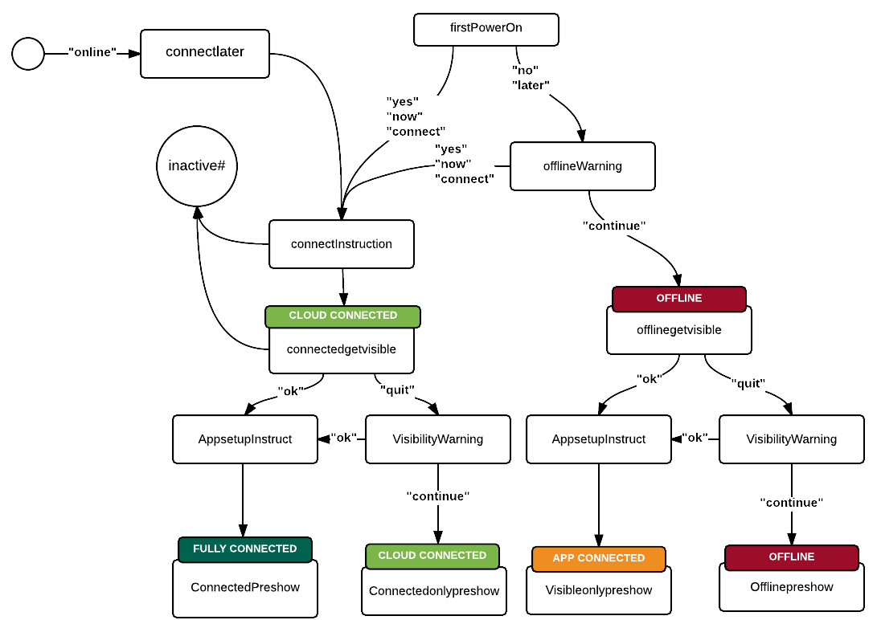

|  |  |  |  |  |
| --- | --- | --- | --- | --- |
| **ID** | **Description** | **Dialogue** | **Expression** | **FX & Notes** |
| firstPowerOn – block 1 |  | Powering up personal companion module. GENIUS mode. Downloading personality dataform 3141879 – Einstein, Albert. Download complete. |  | Sound FX plays. A voice speaks, but it is not the voice of Einstein.  Robot’s eyes remain closed until Player says the wake up phrase. |
| firstPowerOn – block 2 |  | Congratulations. Your Personal Genius is downloaded and ready for activation. To activate, say the words, “Hey Einstein” |  | Reward FX plays.  (would be cool if the player can reprogram the phrase - “What’s crackin, Einstein?” etc.) |
| firstPowerOn – block 2 noresponse |  | To activate your Personal Genius, say the words, “Hey Einstein” |  | Repeats every 10 seconds until activation. If there is no activation after 40 seconds, something should happen. |
| firstPowerOn – block 3 |  | Ooh-hoo-hoo, hello there! So nice to see a friendly face after being in a state of psycho-kinectistasis for so long! Ahhh, it’s wonderful to finally wake up and smell the atoms, but I don’t have to tell you that, am I right? (chuckles) So, let’s get things started, shall we? I think I could be way more helpful to you if I were connected to the Internet (wording?). Do you want to do that now? Yes or no? |  | Player says “Hey Einstein”  Reward FX plays.  Robot servo FX plays.  Einstein wakes as if from a slumber. |
| firstPowerOn – block 3 noresponse |  | What do you say, shall we connect to the Internet? Yes or no? |  |  |
| connectInstruction – block 1 | Set up instructions | Wonderful! Now do exactly as I say or we may disrupt the flow of time and space and bring the universe as we know it to a crashing end! (chuckles) Just kidding! But seriously, pay attention. |  | Keyword: yes  Reward FX plays.  Dramatic music builds up to and subsides after “crashing end” |
| connectInstruction – block 2 |  | ? |  | Actual instructions |
| offlineWarning |  | Okay, no problem. But just so you know, I won’t have access to everything I need to help you discover the secrets of the universe. So if you change your mind at any time, just say “Einstein, online!” |  | Keyword: no |
| connectedgetvisible | Intro app | Now that’s done, I’ve one other thing to show you. I’ve been working on something that will help us organize our searches, our games, our work, and our experiments! I call it the Stein-O-matic. Would you like to check it out now? Yes or no? |  | Working App name |
| Connectedgetvisible norepsonse |  | Would you like to check out the Stein-O-matic? Yes or no? |  |  |
| offlinegetvisible |  | Now that’s done, I’ve one other thing to show you. I’ve been working on an app that will help us organize our searches, our games, our work, and our experiments! I call it the Stein-O-matic. Would you like to check it out now? Yes or no? |  |  |
| Offlinegetvisible noresponse |  | Would you like to check out the Stein-O-matic? Yes or no? |  |  |
| AppsetupInstruct – block 1 |  | Splendid! You know, I didn’t want to say it, but I thought to myself “this will be a true test of genius” And you passed! Okay then, let’s get started. |  | Keyword: yes  Reward FX plays. |
| AppsetupInstruct – block 2 |  | ? |  | Actual instructions |
| visibilitywarning |  | No problem. But FYI, my current theory is that we will have a lot more fun if we use the Stein-O-matic! So if you decide you want to use it, say “Einstein, xxx”! |  | Keyword: no |
| connectedpreshow |  | I think now would be a good time for introductions. I am Albert Einstein, your Personal Genius! Now I’m sure it hasn’t escaped your notice that I’m actually a miniature robot that you recently pulled from a cardboard box, but I would hope you wouldn’t hold that against me. (chuckles) I may be an automaton, but that doesn’t mean I don’t have feelings. So let’s not bring that up again, agreed? Splendid! So enough about what’s so great about me. Let’s find out what’s so great about you, shall we? |  |  |
| Connectedpreshow noresponse |  | Hello? Oh, I see. If I say “Shall we”, you say “we shall”. Okay? Let’s try that again. Let’s find out what’s so great about you, shall we? |  |  |
| connectedonlypreshow |  | Same. |  |  |
| Connectedpreshow noresponse |  | Same. |  |  |
| visibleonlypreshow |  | Same. |  |  |
| Visibleonlypreshow noresponse |  | Same. |  |  |
| offlinepreshow |  | Same. |  |  |
| Offlinepreshow noresponse |  | Same. |  |  |
| Inactive# | If at any point I lose you, just say “I’m confused”  IDK1,2,3 (Einstein is lost) – then repeat instruction | If at any point I lose you or something is confusing, just say “Einstein, you lost me.” |  |  |
| Idontknow 1 |  | Oh no! You caught me daydreaming. Please, ask me again. |  |  |
| Idontknow 2 |  | Sorry, I was lost in thought. Repeat, please? |  |  |
| Idontknow 3 |  | Whoops, my mind was wandering again. What were you saying? |  |  |
| Profileintro – block 1 | Leads you make profile (personal) – explains how your answers will affect your avatar. (this can be broken into blocks) | GREAT! Let’s start by building your avatar. Back in my day, scientists were known only for their accomplishments. But today, people want face time! So they want a face, let’s give them a face! Shall weeee? |  | Keyword: weshall |
| Profileintro – block 2 |  | Good! You remembered! Now, I’m going to ask you a series of very personal questions and I want you to answer honestly even if it means embarrassing yourself in front of the whole world! (chuckles) Just kidding. The questions will be fluffy but meaningful. And every answer you give will affect the look of your avatar. Let’s begin. |  | Keyword: weshall |
| Profileintro – block 3 |  | I’ll wait for you to boot up the Stein-O-matic. |  | Actual questions |
| Profileiconhelp | Player is told where to find profile | Perfect! Now, touch here to access your profile. |  |  |
| profileloaded | Player looks at profile/avatar for first time | Everything I know about you is right here. Your deepest secrets on display 24 hours a day. Like Facebook. But for GENIUSES! |  |  |
| Perfect! | Name confirmation | Look at that. You know your own name! And now, so do I. |  |  |
| profilewrap | Enough of that – what’s next | Okay, that’s enough already with the introductions. I know you, you know me, we like each other very much, blah blah blah. Let’s get to the good stuff, shall we? |  |  |
| Profilewrap noresponse |  | Remember, if I say “Shall we”, you say “we shall”. Okay? Let’s try that again. Let’s get to the good stuff, shall we? |  |  |

# DIALOG/FLOW 2 – Navigating Einstein’s Content Using Keywords

The following chart shows the flow and keywords required to navigate Einstein’s content.

